Pa

ge

0

of

55



**COMP1773 – User Interface Design**

**ID-No : 001102232 Date:29/12/2021**



Contents

Introduction 2

Background information 2

Relevant considerations in UI Design 2

Visibility 2

Consistency 2

Learnability 2

Predictability 3

Feedback 3

Guidelines and standards 3

ISO 9241 – Ergonomics of Human-Computer Interaction 3

Apple (iOS) standards 3

Nielsen’s Usability Heuristics 4

User groups 4

User Persona 1 w/scenario (Looking for a flat) 4

User Persona 2 w/scenario (Looking for a flatmate) 4

Visual Design 6

Colour theory 6

Font terminology 7

Layout design 9

Graphic design 9

Evaluation 10

Critical Reflection 0

Bibliography 0

# Introduction

## Background information

With a proportion of the world’s population living in urban areas expected to increase to 66% by 2050, finding accommodation in London as well as a good flatmate is becoming increasingly challenging amongst millennials.

The aim of this project is to design a mid-fidelity user interface prototype for mobile devices that will allow millennials to search for their ideal flatmate. The interface should be able to support users looking for both a flatmate as well as a flat. How the user navigates between each screen must be clearly shown and at least and at least two designs must be created, and a justification must be made for which design is more appropriate for the task. The final version of the prototype must provide a proof of concept of the proposed mobile experience.

I will be achieving this using a UI wireframing software called Justinmind to create my two mid-fidelity prototypes and the name I have chosen for said prototype is Accomo-Mate. In this report, I will be discussing:

* relevant considerations in designing user interfaces
* guidelines and standards
* two user scenarios
* aspects of the interface’s visual design
* comparison of my two mid-fidelity prototypes

## Relevant considerations in UI Design

### Visibility

* The principle of visibility is that for a user to be able to interact with an interface, they must be able to see it first. In practice, this would mean using techniques such as abstraction to optimise the key elements of the interface so that users can accomplish their goals. Too much on the screen will clutter the interface and hinder the user from achieving their goals.

### Consistency

* Having a consistent interface would allow for users to make sense of what they see. For example, things like using a consistent colour scheme, maintaining the same kind of typography throughout each screen, or keeping recurring elements, like the menu button or a search bar, in the same location. This would help user understand the various components of the interface and allow them to feel in control.

### Learnability

* The principle of learnability refers to how easy it is for users to understand the interface the first time they encounter it, as well as how many it would take for them to become efficient in achieving their desired result. It is crucial that the interface allows for users to accomplish their goals as quickly as possible, and with as little assistance as possible.

### Predictability

* Predictability considers a user’s ability to foresee what will happen before they take any action. If applied successfully, it would reduce the amount of time it would take for a user to complete their goal any time they wish to do it again (learnability).

### Feedback

* Feedback requires the designer to communicate if the user has successfully completed an action or not. A lot of feedback in UI design is usually visual, this could be as simple as a tick appearing when completing a task or a selected element being highlighted in another colour. Feedback aids the user in understanding what the interface is doing, how to proceed further, and what the results of their actions are.

## Guidelines and standards

### ISO 9241 – Ergonomics of Human-Computer Interaction

* A standard established by the International Standard Organisation for how user research should be involved in designing products.
* Specifies the context of use
* Specifies the user and organisational requirements
* Produce design solutions
* Evaluate designs against user requirements

### Apple (iOS) standards

* Clarity – This makes sure that no matter what the situation, information and visuals are presented clearly, and that elements in the interface highlight important content.
* Depth – Interface elements should ‘convey hierarchy, impart vitality, and facilitate understanding’.
* User Control – The interface and all its elements should always give the user the sense that they are the ones in control, not the app. The best user interfaces always strike the correct balance between automaticity from the app and interactivity from the user.

### Nielsen’s Usability Heuristics

* Match between system and the real world – Users should be able to understand what the interface is saying with little to no need to, for example, look up a word’s definition. Specific jargon should be avoided, and real-world conventions should be followed.
* Recognition rather than recall – The user’s need to remember information should be kept to a minimum. The principle of visibility lends itself well in this case as it would ‘promote recognition’[1] and ‘reduce the amount of cognitive effort required from users’[2].
* Aesthetic and minimalist design – Interfaces should make use of abstraction, reducing the content and visual design of the UI to its core and essential components. Elements of the interface should clash with one another in any way.

# User groups

## User Persona 1 w/scenario (Looking for a flat)

Ada is a student starting her first year at university and is looking to moving out to an apartment in London, so that she can reduce the amount of time it would take for her to commute to campus as well as to have the chance to live in her own space. She isn’t particularly fond of having flatmates and prefers to live by herself. To help her find her ideal apartment, Ada had installed Accomo-Mate in advance.

She first opens the Accomo-Mate app. Since she already has an account, the app takes her straight to the Property Search page. There, she makes sure that the ‘Show friends’ checkbox is unchecked and then types in her location of choice into the search bar. After entering, the on-screen map then changes to show the location Ada entered and various map pins appear showing suggestions for available properties to rent. Once she has found a property, she taps on the ‘View More’ button and the app then takes her to the ‘Property Details’ page where it displays more details about the property. Happy with the selection she has made, Ada then presses the ‘Contact Agent’ button to arrange a viewing of the property.

## User Persona 2 w/scenario (Looking for a flatmate)

Ivan has recently started a new job in Central London at a mid-size bank. Outside of work, he is an outgoing and party-loving person who highly values time out with friends. He hopes to meet new people to be his roommates as well as move somewhere closer to where his friends are, and to achieve this, Ivan installs Accomo-Mate.

Since this is the first time Ivan is using the app, the first page he sees is the ‘Sign Up’ page where he enters his details, checks the Terms and Conditions checkbox, and taps to ‘Finish’ button. Afterwards, Ivan is then taken to the ‘Property Search’ screen. He makes sure the ‘Show Friends’ checkbox is checked and then enters a location of choice into the search bar above the map. Various map pins appear across the map as well as a few callouts containing profile pictures of other Accomo-Mate users, which Ivan recognises as his friends currently living in Central London. After selecting a property to view its details, text saying ’10 other users are viewing this property’ appears under the image showcasing the property’s interior. Seeing this, he taps on the message to see the other users and then taps on one of the users’ names to view their profile, where he then proceeds to tap the ‘Add Friend’ button. After some time, the other user adds Ivan to their friends list and the two are able to message each other afterwards.

# Visual Design

## Colour theory

Colour theory is an important aspect of user interface design. Different colours can evoke different emotions from people and have the potential to lighten or sour the moods of the users.

Colours are normally taken from a colour wheel, which houses both primary colours (red, green, and blue) and secondary colours (magenta, cyan and yellow). Everything in between is determined by three things: hue, value, and saturation.

Hue simply refers to a variation or shade of a colour. It is what enables one to be able to identify a colour as ‘red’, ‘orange’, ‘purple’, etc without any gradation in light or darkness.

The value of a colour refers to how bright or how dark a colour is. In UI Design, value can help set good contrasts within the same hue and create different shades of a colour for additional depth.

Saturation refers to a colour’s intensity. Colours of a high saturation appear to be very vibrant, while colour of a low saturation appear duller. Designers use varying levels of saturation in their colour schemes to also set contrasts as well as making sure that colours are not too strenuous to look at for a while.

Figure 1: A colour wheel showing the names of the individual hues.

Image taken from ‘All you need to know about colors in UI Design — Theory & Practice’ (link in bibliography)

Figure 2: A colour wheel showing a scale of value percentage.

Image taken from ‘All you need to know about colors in UI Design — Theory & Practice’ (link in bibliography)

Figure 3: A colour wheel showing a scale of saturation percentage.

Image taken from ‘All you need to know about colors in UI Design — Theory & Practice’ (link in bibliography)

My choices of colour schemes for my two prototypes are as follows:

* Prototype 1: I opted to go for a basic colour scheme; white as my main colour (as majority of the background image was composed of white), black as my secondary colour (to use in text), and a desaturated blue as my accent colour.
* Prototype 2: I went with a more ‘dark mode’ oriented colour scheme; black as my main colour, grey as my secondary colour and a dark gold (#937B1D) as my accent colour. I created this colour scheme as in today’s applications, dark mode themes of the interface are becoming increasingly common, as they put less stress on the eyes (as well as generally being favoured over light mode themes).

## Font terminology

When designing a user interface, font is just as important as colour since users would be reading text in the UI. Therefore, using an appropriate font plays an important role in the appeal of an interface.

Fonts usually fall under three categories: serif, sans-serif, and script. Serif fonts are known for the small lines that are connected at the end of a letter’s stroke. Common examples of serif fonts are Times New Roman, Cambria, and Rockwell. Serifs are generally used in logos, titles, and headings as they can appear striking to certain demographics, mainly users of an older audience.

Sans-serif fonts are basically the opposite of serif fonts; they do not have any lines at the end of a letter’s stroke. Examples of sans-serif fonts include Comic Sans, Arial, and Roboto (the one used in this report). Sans-serif fonts are often the more appropriate choice for text in a document’s body as they are much more legible in large volumes of text.

Script fonts are special in that they are made to resemble real-life handwriting, often identified by the strokes in cursive. Script fonts are mostly used in logos and digital printing.

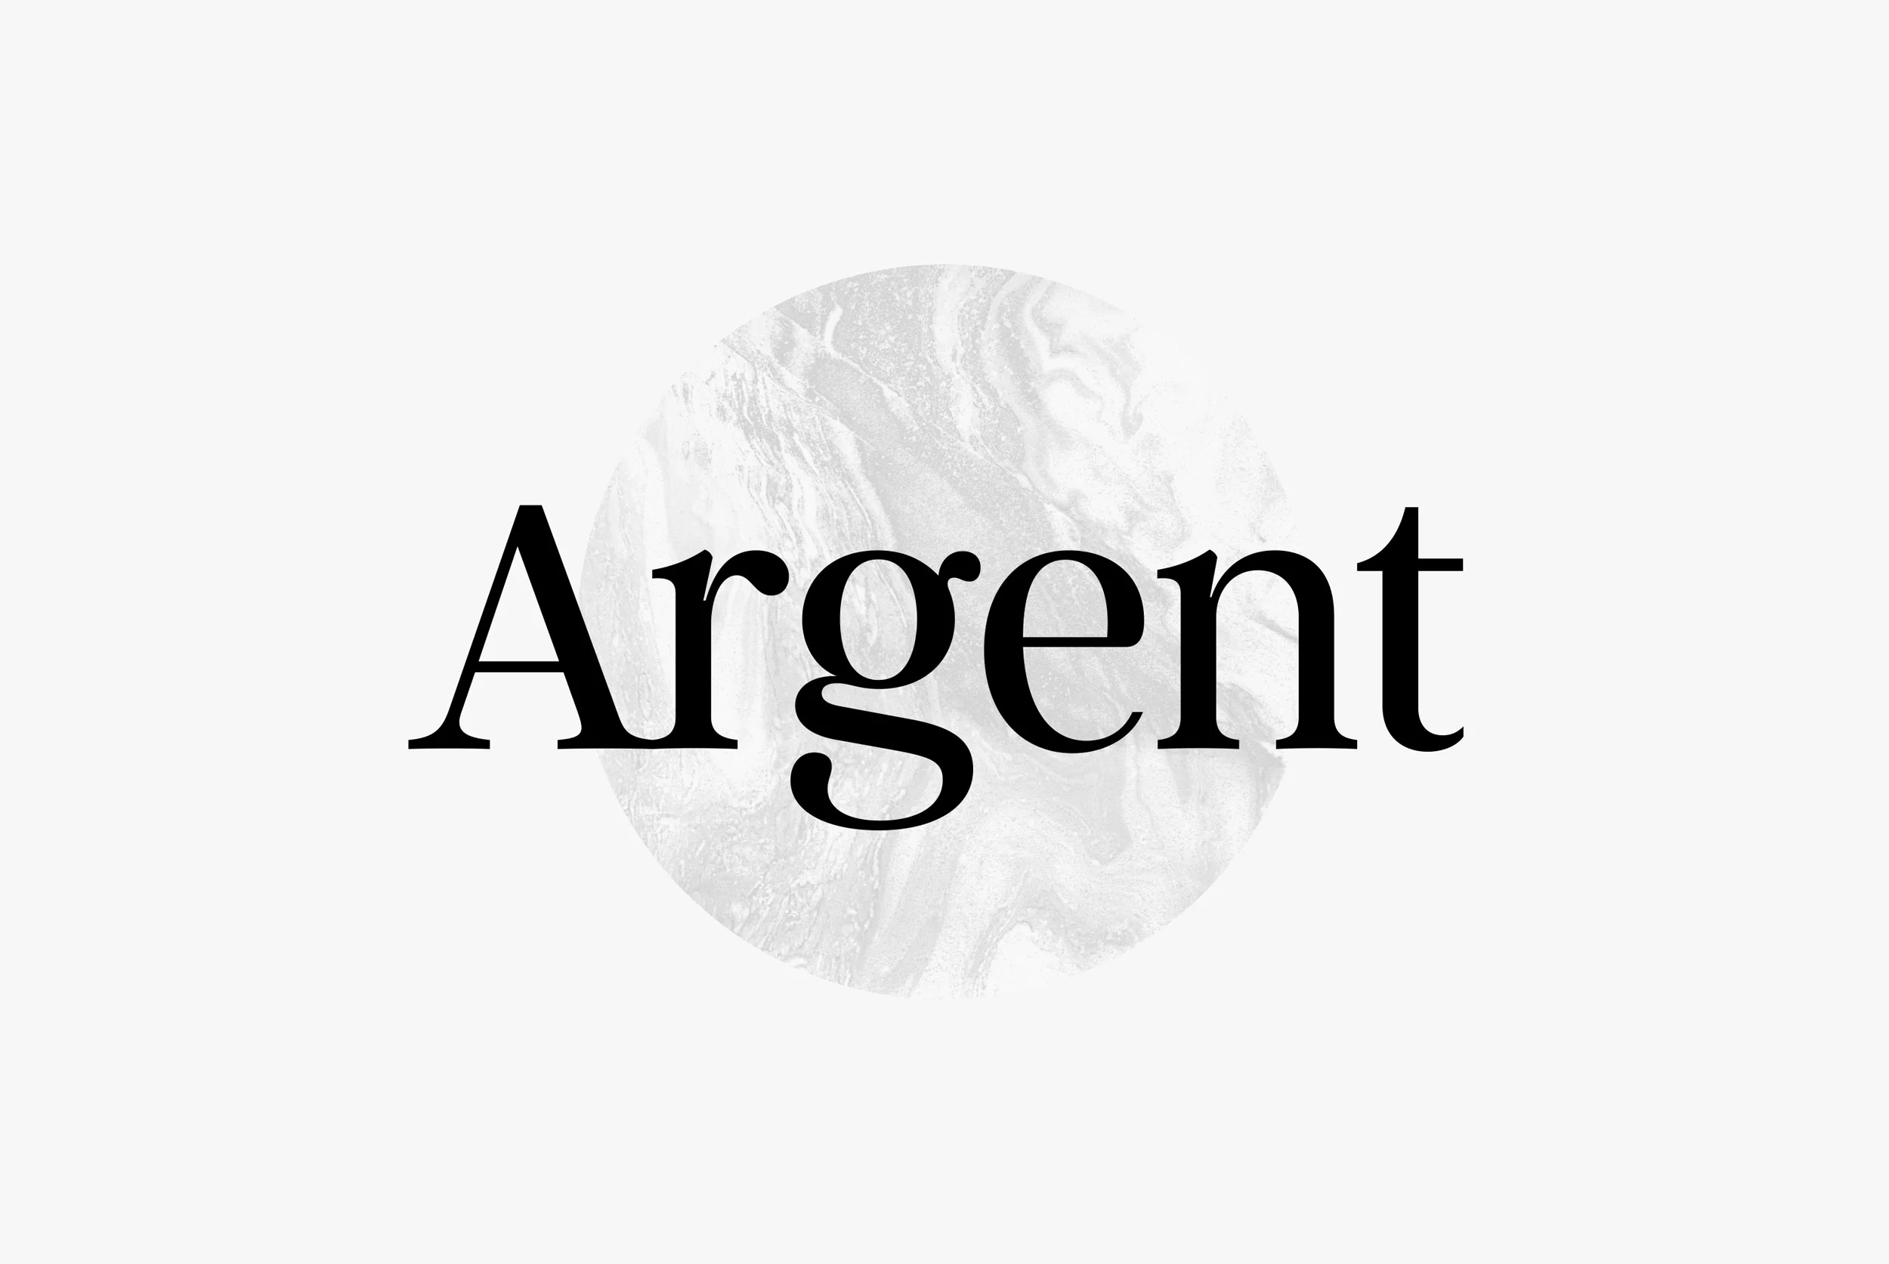

Figure 4: An example of a serif font.

Image taken from ‘20 Essential Typography Terms for Non-Designers’ (link in bibliography)



Figure 5: An example of a sans-serif font.

Image taken from ‘20 Essential Typography Terms for Non-Designers’ (link in bibliography)

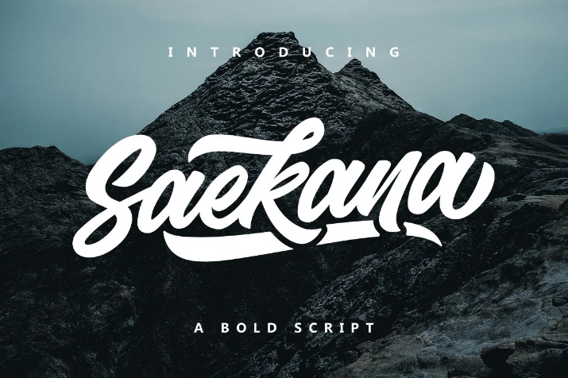

Figure 6: An example of a script font.

Image taken from ‘20 Essential Typography Terms for Non-Designers’ (link in bibliography)

My choice of font for my two prototypes are as follows:

* Prototype 1: I chose Harlow Solid Italic (script) for my logo/title font and Franklin Gothic Medium (sans-serif) as my body text font. I went with this choice as using a script font for my logo and title would be more eye-catching to the user and using a sans-serif font for my body text allows for easier legibility, as well as being more appealing to the target audience.
* Prototype 2: I chose Century Gothic (sans-serif) as my title font and HP Simplified (sans-serif) as my body text font. I had decided on these two as the low weight (thickness) of Century Gothic would complement the ‘dark mode’ colour scheme and the reasons for using HP Simplified for the body text would be the same as mentioned previously (easier legibility at smaller sizes).

## Layout design

The layout design of my prototypes is straightforward, as it will only comprise of two sections: the header and body. The header will contain the title of the screen, the logo, and any navigation buttons to previous screens. The body will contain the screen’s content, and any other interface elements. I have also taken elements like the time and the battery icon into account and have left space for them on either side of the phone’s bezel.

## Graphic design

Maintaining consistency across the graphic elements is important when designing a user interface to ensure user satisfaction. I intend to implement such consistency into my mid-fidelity prototypes.

Elements such as text input fields and buttons would be rounded at the corners and have a border weight of 2 pixels. Buttons would also have a two-colour linear gradient for more appealing visuals. A background image would be visible in each screen, as well as the Accomo-Mate logo. Screen content would be positioned such that the negative space is used, whilst keeping interface elements compact and presentable.

# Low fidelity prototype design

The following screenshots show the general layout that the prototypes will follow. However, there may be differences between this and the final version of the mid-fidelity prototypes.

Sign Up screen #1

Text that can be tapped on to go the password reset screen

Text input fields for user to enter their details

Sign Up screen #2

A list of addresses would show once the user has entered their postcode

Must be checked to proceed. Users can tap the ‘Learn More’ text to read the full terms and conditions

Text input field

Log In screen

Text that can be tapped on to go the sign up and password reset screens

Password Reset screen

Property Search screen

Button that will take the user to the menu screen

Map pins (for suggested properties) and users’ profile pictures (for other Accomo-Mate users) will display here

Property Details screen

Information about the property will go here: rent price (in both per week and per calendar month), amount of beds and bathrooms, general description

Button that will lead user back to previous screen

Menu screen

Buttons that lead the user to different screens

Friends screen

Online: green  
Offline: Red  
Do Not Disturb: yellow

# Comparison of mid-fidelity prototypes

The following will be a comparison of all screens in both mid-fidelity prototypes alongside the low fidelity versions, as well as a formative evaluation on each screen.

|  |  |  |  |  |
| --- | --- | --- | --- | --- |
| Screen | Low fidelity ver. | Mid-fidelity ver. 1 | Mid-fidelity ver. 2 | Evaluation |
| Sign Up #1 |  |  |  | The layout of both prototypes for the first sign up page is almost identical to the low fidelity version, the only difference being that an ‘Email Address’ text input field has now been added to the mid-fidelity prototypes. |
| Sign Up #2 |  |  |  | Like the previous screen, the layout across both prototypes is identical to the low fidelity version. Only difference here being the position of the ‘Gender’ radio button list. |
| Log In |  |  |  | Not much to say here, the layout for both prototypes is the same as the low fidelity version. |
| Password Reset |  |  |  | The position of the ‘Back’ button is now below the title and logo as opposed to being on the left on them. Between the two mid-fidelity prototypes, I would go with the 1st one, as the placeholder text in the text input fields is more legible than the 2nd one. |
| Property Search |  |  |  | For this screen, the positions of the ‘Show friends’ checkbox and the menu button have been changed from how they are in the low fidelity prototype. I prefer the 2nd prototype’s version of this screen as the map goes out the edge of the screen, taking advantage of the negative space |
| Property Details |  |  |  | The layout of the Property Details screen is very similar to its low fidelity counterpart, the difference here being that there is now a ‘Share’ icon next to the ‘Favourite’ icon. I prefer the 1st prototypes version of this screen as the text in the description is more legible further down the screen. |
| Menu |  |  |  | The layout of the 1st prototype closely resembles its concept design, with the logo now being aligned to the centre instead of being above the user’s profile picture, as well as the buttons now having no gap between them. The 2nd prototype, on the other hand, is much more different in its layout. The buttons here are arranged in two columns and three rows. The user’s profile picture, along with their username and status, is now displayed above the buttons and aligned to the centre of the screen. The application version is also visible in both prototypes. I prefer the 2nd prototypes menu screen as the overall arrangement and layout of its elements are much more appealing as far as user interfaces are concerned. |
| Friends |  |  |  | For the ‘Friends’ screen, I prefer the 2nd prototype’s version as makes better use of the negative space, as well as looking more aesthetically pleasing. |

# Evaluation

After comparing the two mid-fidelity prototypes screen by screen and assessing their benefits and drawbacks, I have decided to go with the 1st mid-fidelity prototype. My reasons for this conclusion mostly come from the point of contrast polarity (the contrast between the text and the background), as having black text against a white and grey background allows for easier legibility and bolder graphic elements. This is especially apparent when looking at the placeholder text in the 2nd prototype’s text input fields and the description text in the ‘Property Details’ screen, as not many users would have an easy time perceiving the text without some degree of effort.

However, the 2nd prototype does have advantages of its own, as the colour scheme is more striking from a user standpoint and the fonts used are much more appropriate. Using Century Gothic, as opposed to Harlow Solid Italic, as a title fits better as there may be users who are not as accustomed to reading cursive text as others, as well as users who have visual difficulties, so using a sans-serif font instead of a script font would accommodate for said users.

# Critical Reflection

Over the duration of learning for this coursework, I have learnt a lot in the field of user interface design, such as the importance of colour theory and typography, how to write user personas and scenarios, and the necessity of human-centred design. I also learnt how wireframing software like Justinmind work and how the tools they provide can be used to model functional user interfaces.

However, as I was only using the free version of Justinmind, I could not implement as many features as I would have liked. Also, the specification for this coursework could have been clearer about exactly what each section in the report entailed.

Should I do this coursework again, I would make my two prototypes much more distinct from each other so that I would have more opinions to make and put down in my report.

# Bibliography

*The 5 Principles of User Interface Design, Created Academy*

* <https://www.created.academy/resources/the-5-principles-of-user-interface-design/>

*30 examples of great user persona templates, Justinmind*

* <https://www.justinmind.com/blog/user-persona-templates/>

*How to design user scenarios: best practices and examples, Justinmind*

* <https://www.justinmind.com/blog/how-to-design-user-scenarios/>

*iOS – Human Interface Guidelines, Apple Developer*

* <https://developer.apple.com/design/human-interface-guidelines/ios/overview/>

*All you need to know about colors in UI Design — Theory & Practice, Medium (by Christian Vizcarra)*

* <https://uxdesign.cc/all-you-need-to-know-about-colors-in-ui-design-theory-practice-235179712522>

*10 Usability Heuristics for User Interface Design, Nielsen Norman Group*

* <https://www.nngroup.com/articles/ten-usability-heuristics/>

*20 Essential Typography Terms for Non-Designers, Creative Market (by Mark Schenker)*

* <https://creativemarket.com/blog/typography-terms>

*FreeIconsPNG*

* <https://www.freeiconspng.com>

*Dark Mode vs. Light Mode: Which is Better?, Nielson Norman Group (by Raluca Budiu)*

* <https://www.nngroup.com/articles/dark-mode/>

1. From *‘10 Usability Heuristics for User Interface Design’*. See Bibliography
2. From *‘10 Usability Heuristics for User Interface Design’.* See Bibliography